Understanding Geologic Time
Name: ______________________________
Date: _______________ Per.: _________
Use the “Understanding Geologic Time” interactive on the UCMP “Explorations Through Time” webpage (http://www.ucmp.berkeley.edu/education/explotime.html) to answer the following questions.
- How many pages would be in the “A History of the Earth” book if each page represented 10,000 years of Earth history? __________________________________

- For the events listed below, fill in how many years ago the event happened, and what page it would be on in the “A History of the Earth” book.
Event | Years ago | Page # in book
Formation of the Earth and Moon
Earliest life appears
Early land plants
Largest mass extinction
Dinosaur extinction
Early hominid “Lucy”

- What is the difference between relative date and absolute date? (Use the U.S. history timeline you create to help answer this question.)

- What is the Law of Superposition?

- Fill in the following information for the fossils shown in step 7 of the activity.
Fossil | Fact about the organism | Date the fossil:
Trilobite |  | First appeared:
Brachiopods |  | Height of diversity:
Eurypterids |  | Went extinct:
Ammonites |  | Went extinct:

- Which of the fossils is the earliest (oldest)? _________________________________________

- What is radiometric dating, and what does it tell us?

- Based on the data from the radiometric dating of the volcanic ash layers, what is the age range for the layer of rock the ammonite fossils are found in? _____________________________________

- The geologic time scales starts with the formation of the Earth. When did the Earth form? __________________________________

- Fill in the following information for the eons and eras in the geologic time scale.

Time Period |  |  | Fact | Millions of years ago
Eons | Phanerozoic
Proterozoic
Archean
Pre-archean
Eras |  | Cenozoic
Mesozoic
Paleozoic

- Use the information from the geologic timeline to identify what period each of the following events occurred in.

- Animals first appear in the fossil record: _____________________________________
- Evidence of life on land: ____________________________________
- First trees and forests appear: ________________________________
- Pangaea forms: _______________________________________
- Largest mass extinction occurs: _____________________________
- Dinosaurs roam the earth:__________________________________
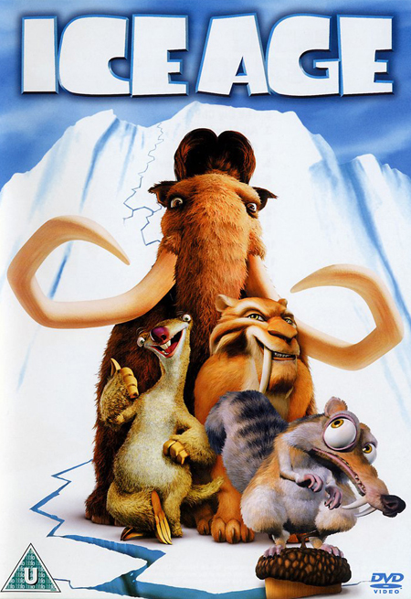
- Dinosaurs go extinct:_______________________________________
- Mammoths, saber-toothed cats, giant sloths, humans, and ice ages
(aka, when the movie “Ice Age” takes place): ___________________________

