Snack Tectonics
In the spaces below, record what portions of the Earth each of the materials you will be using represent.
Frosting = __________________________________
Fruit Roll-Up = ______________________________
Graham Cracker = ___________________________

Divergent Boundary
1. How does the frosting represent the physical characteristics of the asthenosphere?

2. What did you observe happening as you modeled the divergent plate boundary? What process does this represent?

3. What land feature would be created at this boundary type?

4. Draw a picture showing the direction of plate movement and convection in the asthenosphere for a divergent plate boundary. Next to the drawing explain with words why the plates diverge.

Convergent Boundary
Continental - Oceanic
5. What did you observe happening as you modeled the convergent boundary? What process does this represent?

6. What land feature would be created at this boundary type?

Continental – Continental
7. What did you observe happening as you modeled the convergent boundary? What process does this represent?

8. What land feature would be created at this boundary type?

9. Draw a picture showing the direction of plate movement and convection in the asthenosphere for a convergent plate boundary. (You may use either type of convergent plate boundary you modeled.) Next to the drawing explain with words why the plates converge.

Transform Boundary
10. What did you observe happening as you modeled the transform boundary?

Conclusion Questions
11. Which boundary type did you not model in this activity? Create a slide with directions that could be added to this activity in order to model this type of boundary.
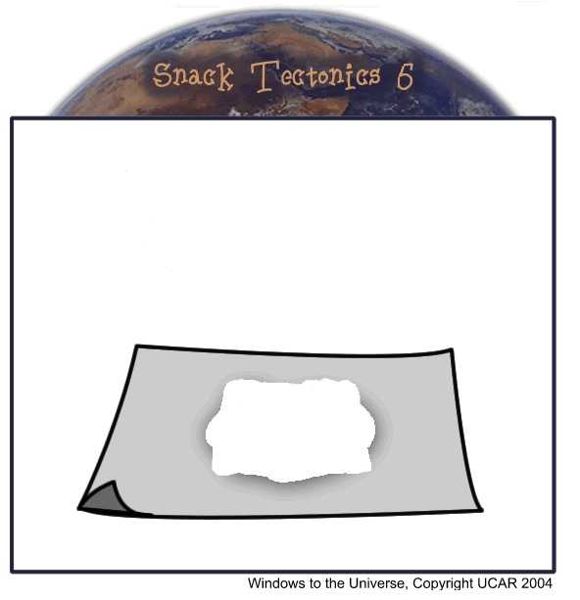
12. Why is it important to know what types of plates are interacting at convergent plate boundaries, but not at divergent or transform boundaries?

