Analysis (Use the compare and contrast sentence frames.)

- How were the computer graphs created when you moved away from the motion detector similar?

- How were the computer graphs created when you moved away from the motion detector different?

- How do the slopes of the two lines compare?

- How were the computer graphs created when you moved toward the motion detector similar?

- How were the computer graphs created when you moved toward the motion detector different?

- How do the slopes of the two lines compare?

- What does the slope of the line on a distance-time graph represent? What did you see in the activity to support this?

- Compare and contrast the graphs from parts 1 and 2 (away from the motion detector) to the graphs from part 3 and 4 (toward from the motion detector).

Summarize

Constant, steady motion produces a line on a distance-time graph that is _______________________________________. The slope of the line represents the object’s _______________________. The ________________________ the object is moving, the ________________________________ the slope.

Application

- Describe the motion that would produce the graphs below. (See the sequencing sentence frames.)

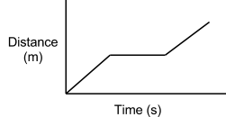

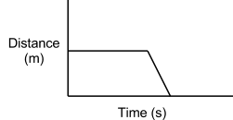

- Predict what you think the line on a distance-time graph would look like if the motion was not constant and steady.
