How Do You Graph Motion?

Purpose: To investigate how motion is displayed as a graph.

Data

Sketch the line from the computer graph for each of the following types of motion, and then describe the shape of the line.

Motion Relative to the Motion Detector | Graph  (Sketch the shape of the line) | Description of the shape of the line  (Straight? Curved? Diagonal? Direction it’s going?)
Slowly away | 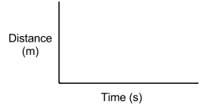
Quickly away
Motion Relative to the Motion Detector | Graph | Description of the shape of the line
Slowly towards
Quickly towards
Standing still

